***Austin-based Company Designs Spinal Implants Based on Surgeon Feedback***

*Company’s latest offering: A cervical plate with a unique locking mechanism*

AUSTIN, TEXAS, Dec. 22, 2014 – Just as with an artist or an auto mechanic, surgeons have their favorite set of instruments. Genesys Spine, an Austin-based medical device manufacturer, is helping meet the unique needs of these surgeons, and ultimately working toward improving surgical results for patients.

*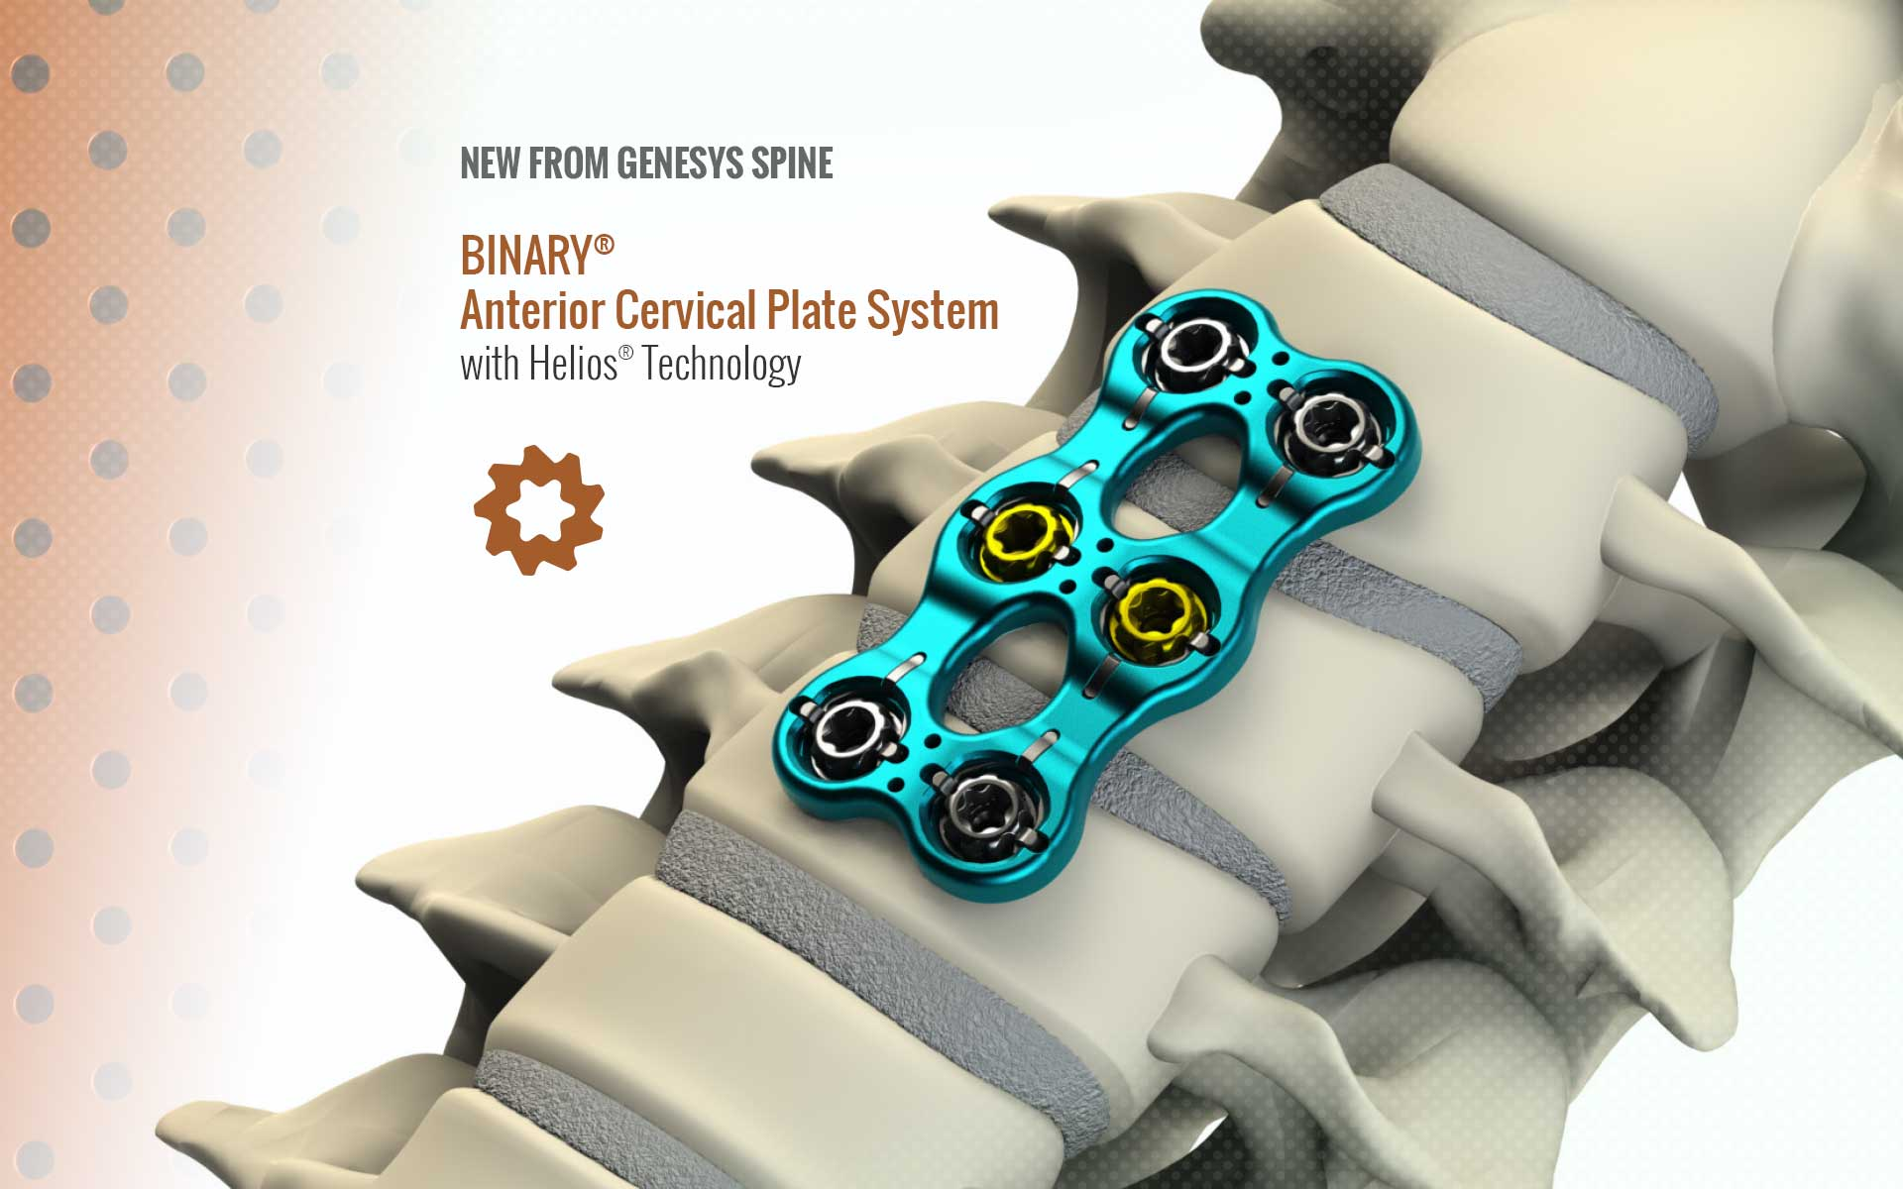The BINARY® Anterior Cervical Plate System has screw heads that lock into place thereby helping surgeons complete surgeries more efficiently, with fewer steps and fewer instruments.*

The latest offering from the Genesys Spine portfolio is a novel product designed to reduce the number of tools and steps required in cervical spine surgery and reduce patient time on the operating table. The patented product is called the BINARY® Anterior Cervical Plating System and is an implant used to stabilize the cervical spine during the development of a solid spinal fusion. It is offered to patients with degenerative disc disease, deformities of the spine, trauma (including fractures), and tumor pathology. The system consists of:

Multi-segmented titanium bone plates of various sizes and lengths

Titanium bone screws in various diameters and lengths

Associated instrumentation

**Helios® Technology makes the system unique**

There are competing products on the market, but those systems tend to require additional instruments and surgical steps, as well as an additional plate or mechanism to hold the screws in place, all of which lead to extended time in surgery and the need for additional anesthesia. But the new BINARY Plating System incorporates patented Helios Technology from Genesys Spine, which is a combination of counter rotation functionality, anti-backout functionality, and what is called their “Zero-step” feature: A clever ratcheted screw-head system that locks into place with a satisfying click.

Genesys Spine Principal Joshua Kaufmann explains: "Zero-step refers to the fact that once our cervical screw is inserted into place, there is no additional process, additional surgical instrument, or additional surgical steps required to lock the screws in place to complete the surgery. Helios Technology helps the surgeon complete the surgery more efficiently, and helps provide a workspace that isn’t cluttered with needlessly complicated surgical instruments.”

*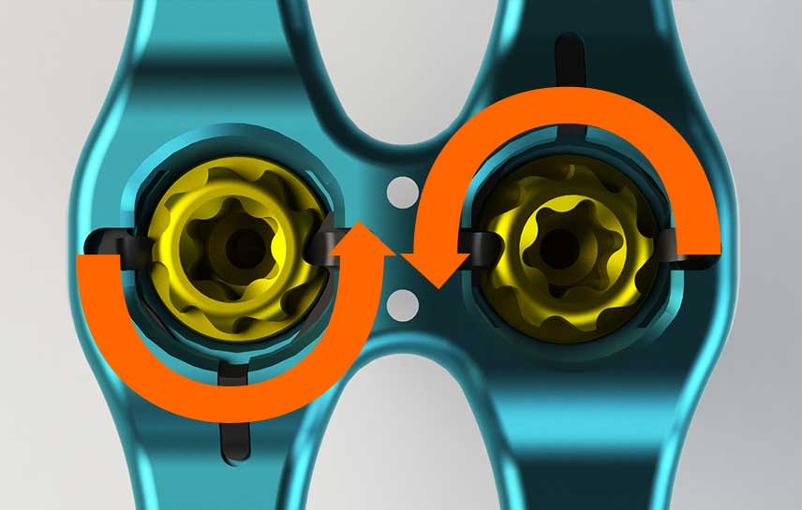The screws in the patented Helios technology system click into place, providing the surgeon with visual, aural and tactile feedback.*

**Listening to the surgeon community**

The company developed the patented Helios Technology after gathering feedback from the surgeon community. "We listened to our surgeons who told us they wanted a better implant product, more efficient surgical instruments, and reduced surgical time," Kaufmann said.

An added bonus that the Genesys Spine team didn’t foresee: The surgeons appreciate being able to see, hear, and even feel when the screws lock into place. "Our surgeons get visual, audible, and tactile feedback from our Helios locking mechanism, and they seem to really like this feature,” said Kaufmann. “They tell us it gives them confidence that the lock is fully engaged and working."

CONTACT:

<http://genesysspine.com/products/cervical/binary-anterior-cervical-plate-system>

Joshua Kaufmann  
Principal, Genesys Spine  
[Josh.Kaufmann@genesysspine.com](mailto:Josh.Kaufmann@genesysspine.com%20) ,   
(512) 381-7070  
1250 S. Capital of Texas Highway  
Building 3, Suite 600  
Austin, TX 78746

**More about the BINARY Anterior Cervical Plate System**

This system is intended for anterior screw fixation to the cervical spine. It is to be used in skeletally mature patients as an adjunct to fusion of the cervical spine (C2 to C7). The system is indicated for use in the temporary stabilization of the anterior spine during the development of cervical spinal fusion in patients with degenerative disc disease (as defined by neck pain of discogenic origin with degeneration of the disc confirmed by patient history and radiographic studies), spondylolisthesis, trauma (i.e. fractures or dislocations), tumors, deformity (defined as kyphosis, lordosis, or scoliosis), pseudoarthrosis, failed previous fusion, and/or spinal stenosis.

**About the surgery**

There are an estimated 180,000 cervical fusion procedures performed in the United States each year to relieve compression on the spinal cord or nerve roots. Fixation is provided by bone screws inserted into the vertebral body of the cervical spine using an anterior approach.

**About Genesys Spine**

Founded in December of 2009, Genesys Spine was started by veterans of the spinal device start-up industry. The founding partners have used their industry knowledge and input from existing surgeon relationships to introduce, into a mature spinal fusion market, an array of medical implants and instruments with novel characteristics. These devices, with their proprietary features, all remain within existing parameters for today’s current reimbursement codes.

“Our growth and success stems from our commitment to listen and respond to the needs of the medical community,” said Genesys Spine Principal Joshua Kaufmann.